KPI SQL Queries

1.Total Revenue
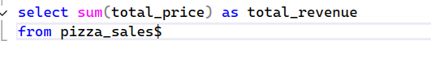

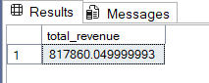
2. Average order value
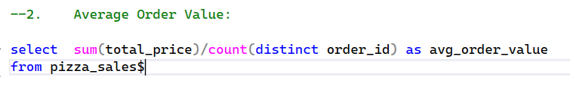

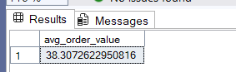

3. Total Pizzas Sold

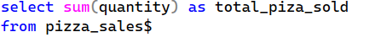
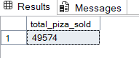
4. Total Orders
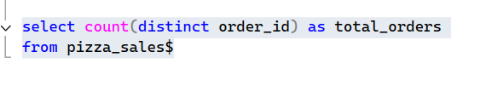
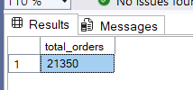
5. Avg. Pizzas per Order
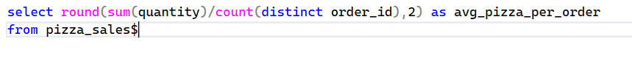
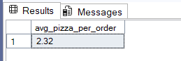
6. Daily Pizza order trends
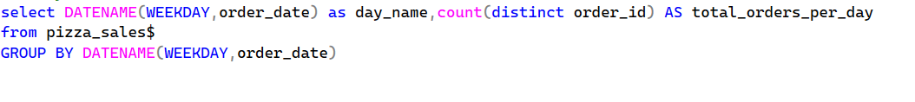
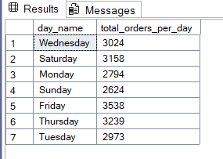
7. monthly Trend for Total Orders:
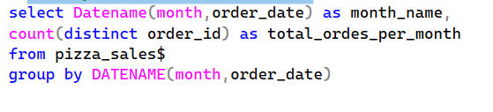
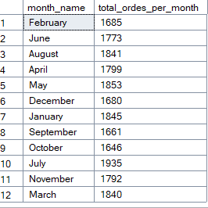

8. Percentage of Sales by Pizza Category
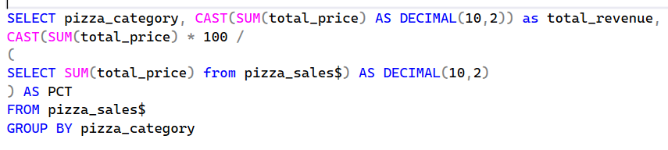
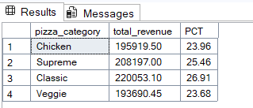

9. Percentage of Sales by Pizza Size
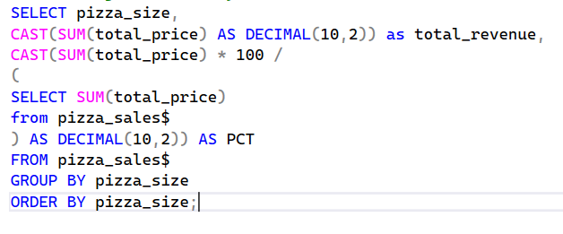
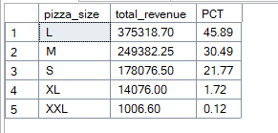

10. Total Pizzas Sold by Pizza Category
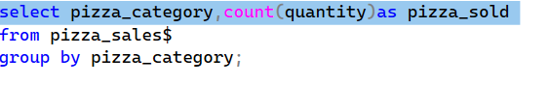
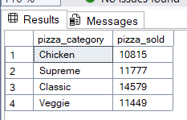

11. Top 5 Best Sellers by Revenue:
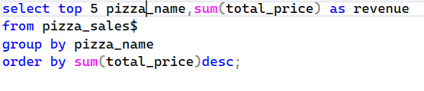
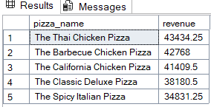

12. bottom 5 sellers by revenue
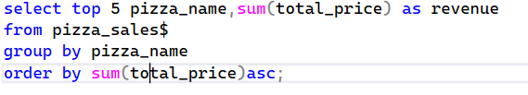
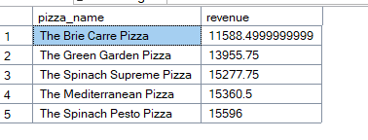

13. top 5 sellers by Total Quantity
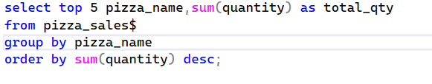
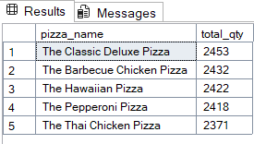

14. --Bottom 5 sellers by Total Quantity
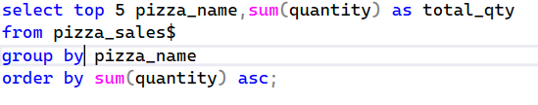
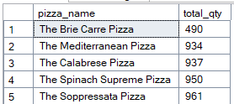

15. Top 5 sellers by Total Orders
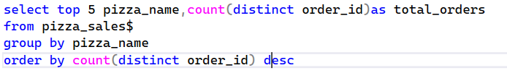
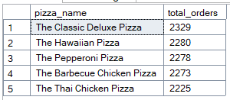

16. Bottom 5 sellers by total orders
